GREEN COMPUTING FOR INTELLIGENT AUTOMATION SYSTEMS
Sweetha.T
Department of Computer Science with Data Analytics KPR COLLEGE OF ARTS SCIENCE AND RESEARCH
Dr.B. Ramesh Kumar MSc, MCA, M.Phil., NET, SET (Ph.D.).,

Sustainable Autonomy: Green Computing Strategies for Agentic AI Systems

The move from traditional, reactive artificial intelligence to Agentic AI represents a major step toward digital autonomy. While traditional models process single prompts to generate individual responses, agentic systems operate as continuous, goal-driven loops. They independently manage complex workflows, utilize external tools, self-correct, and collaborate within multi-agent networks to achieve long-term goals.

However, this shift brings significant environmental challenges. Agentic AI systems run persistent cycles of perception, reasoning, and tool use, demanding far more continuous energy than isolated inference calls. This leads to sharp increases in data center electricity consumption, faster hardware wear, and a higher overall carbon footprint for autonomous software.

To separate AI-driven automation from environmental harm, modern software architecture must balance two priorities: using AI to promote sustainability by optimizing real-world resource use, and ensuring AI itself is sustainable by designing efficient software, memory systems, and coordination protocols that minimize computation costs.

Addressing the main computational bottlenecks of agentic workflows requires a layered green computing strategy:

- Algorithmic and Memory Efficiency: Use neuro-symbolic routing to offload logic tasks to low-power rule engines, combined with active context-compaction techniques to control the steep energy growth from large model memory demands.
- Decentralized Edge Coordination: Shift from centralized cloud telemetry to edge-optimized peer-to-peer agent networks that transmit compact semantic intent embeddings rather than bulky raw text.
- Carbon-Aware Infrastructure Orchestration: Integrate execution schedulers with real-time electricity grid data to dynamically schedule delay-tolerant background tasks when and where renewable energy is most available.

By focusing on eco-efficiency alongside accuracy, developers can create scalable autonomous systems that advance digital transformation while supporting global sustainability goals.

Literature Review and Theoretical Background

Artificial intelligence has rapidly evolved beyond traditional, fixed input-response designs into fully autonomous, goal-driven networks, outpacing existing green computing frameworks. Early sustainability studies—like the influential research by Strubell et al. (2019)—primarily examined the high carbon emissions during model training. As foundational models became widely used commercially, attention shifted to the growing environmental impact of operational inference, where large-scale querying surpasses the initial training energy costs. Recent data, however, shows that the rise of generative video and continuous execution loops introduces complex scaling challenges that strain current efficiency metrics.

At the heart of this issue are bottlenecks in the autonomous Perception-Reasoning-Action (PRA) loop. Unlike typical conversational models that clear memory after a single response, agentic systems continually log intermediate plans, environmental data, and multi-step tool interactions into their history. In standard transformer architectures, this causes the context window to grow rapidly, resulting in quadratic complexity (O(N2)\mathcal{O}(N^2)) in the attention mechanism. This expansion heavily stresses the accelerator’s key-value (KV) cache memory, forcing data center hardware to operate at high energy levels and significantly increasing cooling demands.

To address these challenges without compromising agentic AI capabilities, current research explores concepts like “Frugal AI” and adaptive edge computing. Compression techniques such as 3-bit or 4-bit quantization can reduce energy use by up to 79% on mobile and edge devices, but they also cause a 20% to 30% decline in performance on complex mathematical and sequential reasoning tasks. This highlights a key limitation in existing software designs: traditional Green AI approaches treat inference as a static event, rather than a persistent, evolving process. Consequently, there is a pressing need for dynamic, system-level solutions—including neuro-symbolic task routing and carbon-aware runtime controls—to enable scalable digital autonomy aligned with global climate goals.

Introduction: The Dawn of Agentic AI and the Environmental Imperative

Artificial intelligence stands at a crucial turning point in its development. For many years, machine learning models functioned as static, reactive systems. These traditional models—from simple convolutional neural networks to early transformer-based Large Language Models (LLMs)—followed a straightforward input-output process: a user submitted a prompt or data, and the model responded with a single, deterministic or probabilistic output.

Today, the field is evolving with the emergence of Agentic Artificial Intelligence (AAI), which represents a move toward fully autonomous, goal-driven systems. Rather than depending on step-by-step instructions, these agents perform complex, multi-modal workflows, adapt to dynamic environments, self-evaluate their outputs, and collaborate within networks of agents to accomplish sophisticated human objectives (Murugesan, 2025).

While Agentic AI holds transformative promise in enterprise automation, scientific discovery, and smart infrastructure, it also poses a growing and complex environmental challenge. Traditional AI workloads typically involve predictable, temporary computational efforts, often measured in Floating Point Operations (FLOPs) during distinct training and inference stages. In contrast, Agentic AI operates continuously—engaging in cycles of perception, environmental scanning, internal reasoning, tool utilization, and self-correction.

This persistent activity significantly increases data center energy consumption, accelerates hardware degradation, and raises the carbon footprint of digital infrastructure. A single task managed by an agentic workflow can trigger hundreds of iterative LLM calls, database lookups, and API requests, exponentially multiplying the carbon cost of that task.

This situation presents an urgent dual responsibility for the computer science community: to promote the advancement of autonomous intelligence while mitigating environmental impact. This balance reflects a central ethical principle in AI research—balancing AI for sustainability with the sustainability of AI itself (van Wynsberghe, 2021).
- AI for Sustainability positions autonomous agents as tools to lower human ecological footprints by improving systems such as smart grids, reducing agricultural waste, and optimizing supply chains.
- Sustainability of AI emphasizes designing agents’ internal structures, algorithms, communication methods, and execution environments to reduce energy, water, and carbon consumption.

This chapter examines the key technical strategies necessary to develop, deploy, and sustain eco-friendly Agentic AI, providing a framework for responsible, environmentally conscious digital autonomy.
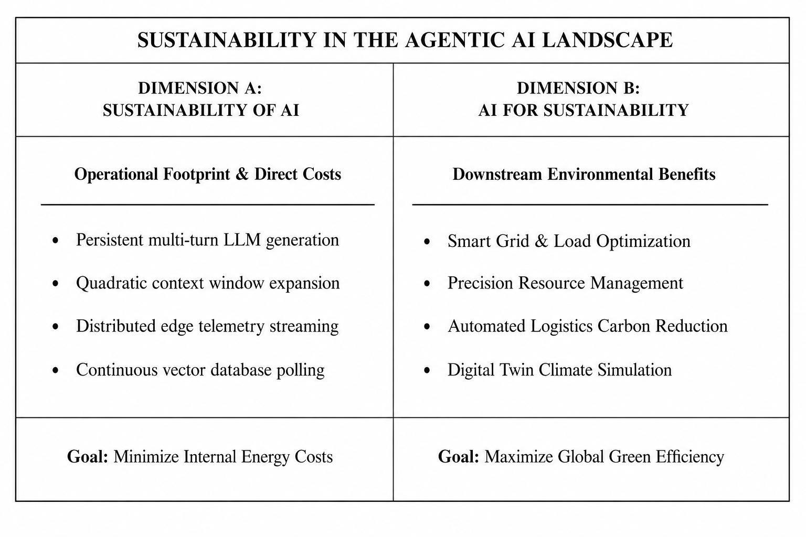

Diagram 1: The Dual Dimensions of Sustainable Agentic AI

Theoretical Framework: The Perception-Reasoning-Action Energy Loop
To effectively apply green computing strategies in agentic AI architectures, engineers need to first identify and analyze the main sources of energy consumption. While traditional computing profiling focuses on CPU/GPU usage and memory access, Agentic AI’s energy demands are primarily driven by the continuous Perception-Reasoning-Action (PRA) loop. Each stage of this loop has unique computational patterns, resource constraints, and carbon impacts that require targeted mitigation efforts.

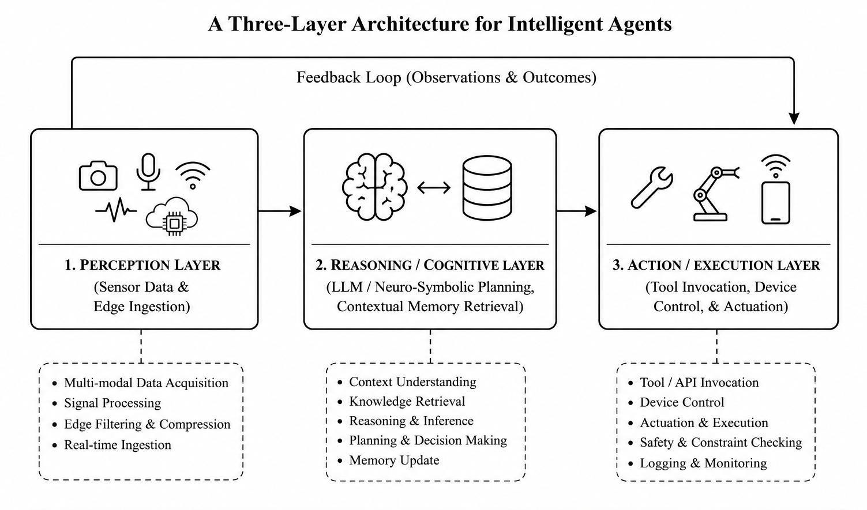

Diagram 2: Theoretical Framework

The Perception Layer

The Perception Layer acts as the agent’s sensory gateway, handling data intake and preprocessing. Agents continuously gather unstructured information from various sources, such as real-time IoT sensor data, live video streams, enterprise databases, and web scraping feeds.
From an energy standpoint, the main challenge here is the overhead of data ingestion and constant input polling. Continuously processing raw, high-quality data without local filtering leads to significant energy consumption, especially due to network transmission and the initial steps of tokenization or embedding generation.

For example, converting raw video into high-dimensional vector embeddings using continuous vision-language models places heavy strain on both edge and cloud infrastructure, making it unsustainable. Green computing approaches at this stage should emphasize semantic downsampling, event-driven data activation, and localized delta-processing—so that the agent only processes data changes that are relevant to its core objectives.

The Reasoning and Cognitive Layer

The Reasoning Layer is the most carbon-intensive part of the Perception-Reasoning-Action cycle. At this stage, the agent acts as a cognitive engine, leveraging large language models, neuro-symbolic planners, and advanced memory retrieval systems (Hosseini & Seilani, 2025). Rather than simply producing a direct response to a goal, the agent undertakes multi-step planning, breaks down tasks into sub-problems, consults external knowledge sources through Retrieval-Augmented Generation (RAG), and runs self-reflection loops to critique and improve its internal reasoning before taking action.

This process requires substantial computational power. Each reasoning step involves generating multiple turns of tokens. In typical transformer architectures, the attention mechanism’s computational complexity grows quadratically with the length of the context:


where NN represents the number of tokens in the context window. As an agent accumulates historical context, tool logs, and multi-agent dialogue, NN grows rapidly. This expansion of context forces data center GPUs to remain in high-power states longer, increasing both direct electricity use and the indirect carbon costs tied to cooling infrastructure (Kaack et al., 2022).

The Action and Execution Layer

After reaching a cognitive decision, the agent moves into the Action Layer. Here, actions take the form of tool calls, API requests, code generation and execution within secure sandboxes, or commands sent to physical devices.

The energy consumption at this stage shifts from intense floating-point computations to overhead from distributed systems, network data serialization, and cross-platform communication. In multi-agent setups, one agent’s action often triggers new perception and reasoning cycles in others.

Without careful communication controls, multi-agent systems risk falling into “infinite execution loops” or conversational deadlocks, where agents endlessly clarify instructions without progressing toward the human goal. This uncoordinated activity consumes vast cloud computing resources, turning network infrastructure and distributed nodes into hidden sources of carbon emissions.

Core Green Computing Strategies for Agentic AI

Algorithmic and Structural Efficiency

To maximize the sustainability of agentic workflows, the foundational algorithms behind agent execution must be redesigned. Relying solely on large, monolithic LLMs for every reasoning step is inefficient. Instead, architectures should move toward hybrid, heterogeneous configurations.

Neuro-Symbolic and Hybrid Task Modeling:
Deep learning models excel at pattern recognition and natural language generation but are inefficient for deterministic logic, math, and structured planning. Combining Symbolic AI techniques—such as rule engines, logic programming, and classical planners—with generative models forms a neuro-symbolic framework. For example, when facing a scheduling problem, an agent can delegate it to a classical constraint solver that uses minimal CPU resources, instead of consuming thousands of GPU tokens trying to solve it via probabilistic prediction.

Dynamic Execution Control and Guardrails:
Green computing requires embedding “green defaults” in agent orchestration frameworks. Dynamic execution control acts like a cognitive thermostat—agents should operate within strict token and iteration limits. Additionally, routing layers should evaluate task complexity before engaging heavy generative models. If a request can be handled by a local regex parser or a lightweight specialized classifier, the system should bypass the costly generative reasoning loop, reserving high-power GPU resources for more complex, ambiguous problems.

Model Compression, Distillation, and Quantization:
For tasks requiring generative power, agents should use task-specific Small Language Models (SLMs) optimized through advanced post-training quantization techniques, such as converting 16-bit floating-point weights to 4-bit integers (FP16→INT4), along with structural pruning. Knowledge distillation further allows a compact, optimized 7-billion parameter agent to perform local tool calls and data extraction with an energy footprint vastly smaller than a massive, closed-source trillion-parameter model, while maintaining comparable accuracy within its domain.

Advanced Algorithmic Strategies: Context Window Compaction and Memory Truncation

In ongoing multi-agent interactions, the rapid growth of the context window is a key factor driving non-linear increases in computational cost. As agents delve into deep reasoning chains, the key-value (KV) cache—which stores transformer attention keys and values over extended conversations—expands linearly, severely limiting GPU throughput and increasing SRAM/VRAM energy consumption.

Technical Details
To address KV cache bloat, efficient agentic architectures use Dynamic Context Pruning and Hierarchical Memory Summarization. Rather than continuously appending every tool log and raw response to the context window, a background semantic compression layer assesses token importance based on an information entropy threshold.
Tokens with low semantic value—such as formatting syntax or redundant conversational filler—are dynamically removed from the KV cache. Meanwhile, long-term logs are condensed into dense, low-dimensional vector embeddings and moved out of active GPU memory to cold vector storage, where they can be accessed later through semantic relevance queries (Ghasemi et al., 2025).
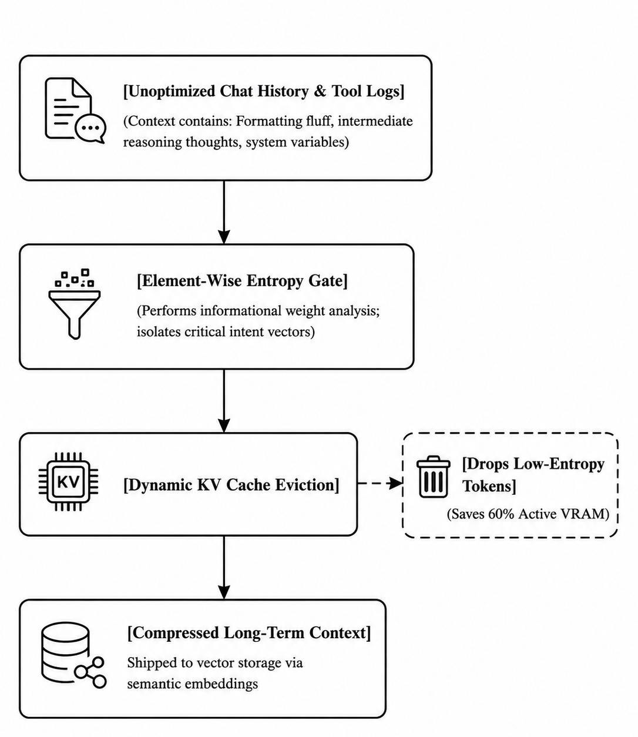

Diagram 3: Energy-Efficient Agentic KV Cache Compaction Layer

Comparative Analysis of Sustainability Frameworks

When designing an ecosystem of agents, engineers must balance execution speed, accuracy, and carbon output. The table below provides a structural paradigm for deciding which green framework to employ based on the task type.
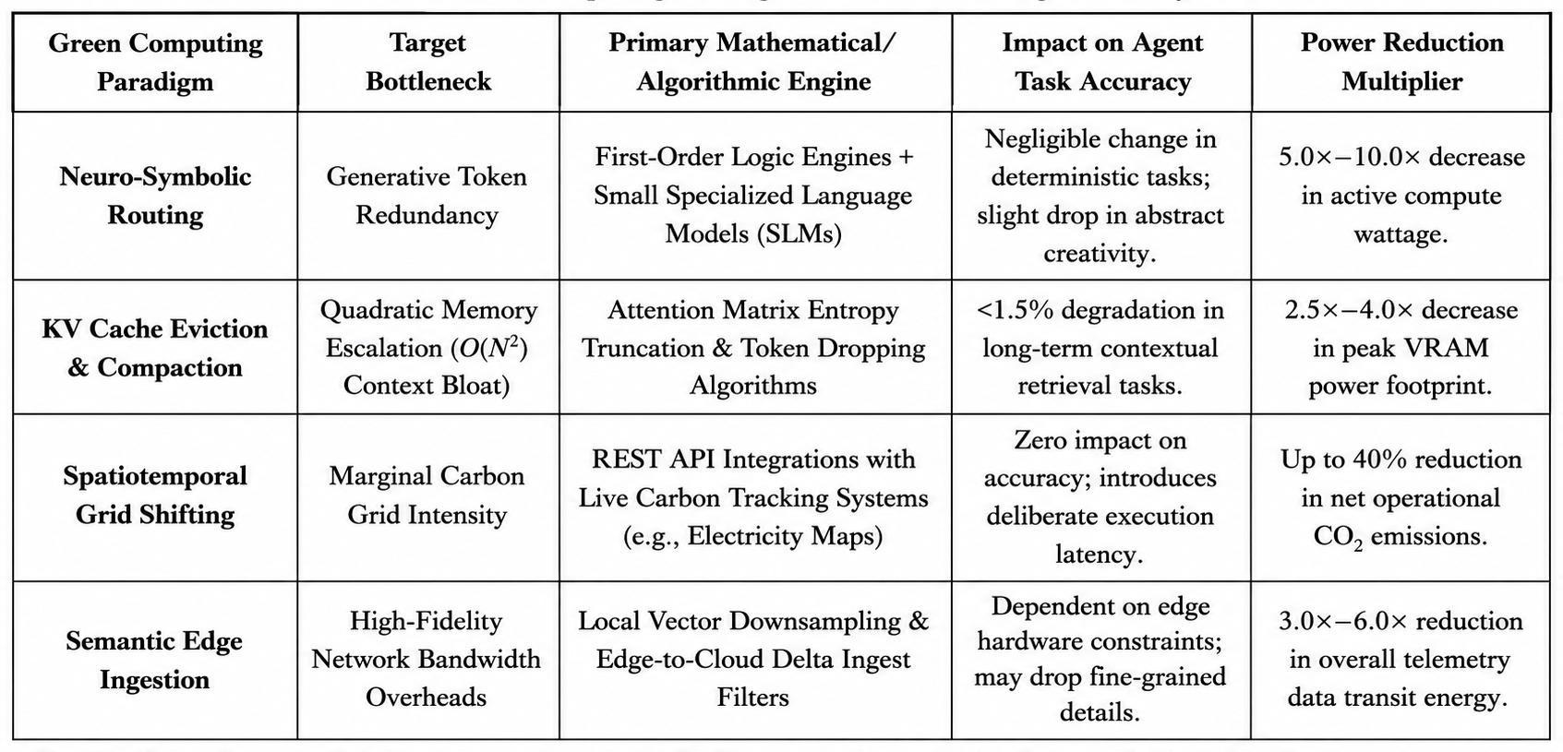
Table 1: Structural Profile of Green Computing Paradigms for Autonomous Agents

Communication and Edge Coordination Optimization

As agentic AI systems expand across global networks, reducing data transmission and optimizing distributed communication are essential for green engineering.

Decentralized Coordination Frameworks:
Centralized cloud architectures require edge sensors to stream raw data continuously to distant data centers, resulting in high network routing and energy costs across global telecom infrastructure. Moving to decentralized, peer-to-peer multi-agent coordination enables localized agents to process, filter, and reach consensus directly at the network edge (Daset al., 2024). By using federated architectures, agents send only highly compressed semantic updates or vector differences to the cloud, significantly lowering core network power consumption (Luetal., 2022; Nagaetal., 2024b).

Cross-Layer Edge Co-Design:
When edge agents interact with cloud systems, communication protocols should be co-designed with the underlying physical network layers (e.g., 5G-Advanced and 6G). Semantic communication protocols transmit low-dimensional intent embeddings instead of literal token strings, allowing the receiver to reconstruct context locally. This approach reduces
wireless transmission energy, avoids packet collisions, and stabilizes power use during dense multi-agent exchanges.

Spatiotemporal Workload Shifting for Distributed Agent Workflows

Agentic AI often involves long-running, asynchronous batch tasks like multi-agent simulations, self-training cycles, or knowledge graph construction. These non-urgent tasks are ideal for carbon-aware scheduling (Martinez & Silva, 2025).

    - Temporal Shifting: Delay execution of non-critical reasoning tasks in a local region until renewable energy availability (solar, wind, hydro) peaks in the local grid.
    - Spatial Shifting: Dynamically migrate stateless multi-agent workloads across global data centers using container orchestration platforms (e.g., Kubernetes) to locations where clean energy is currently abundant.
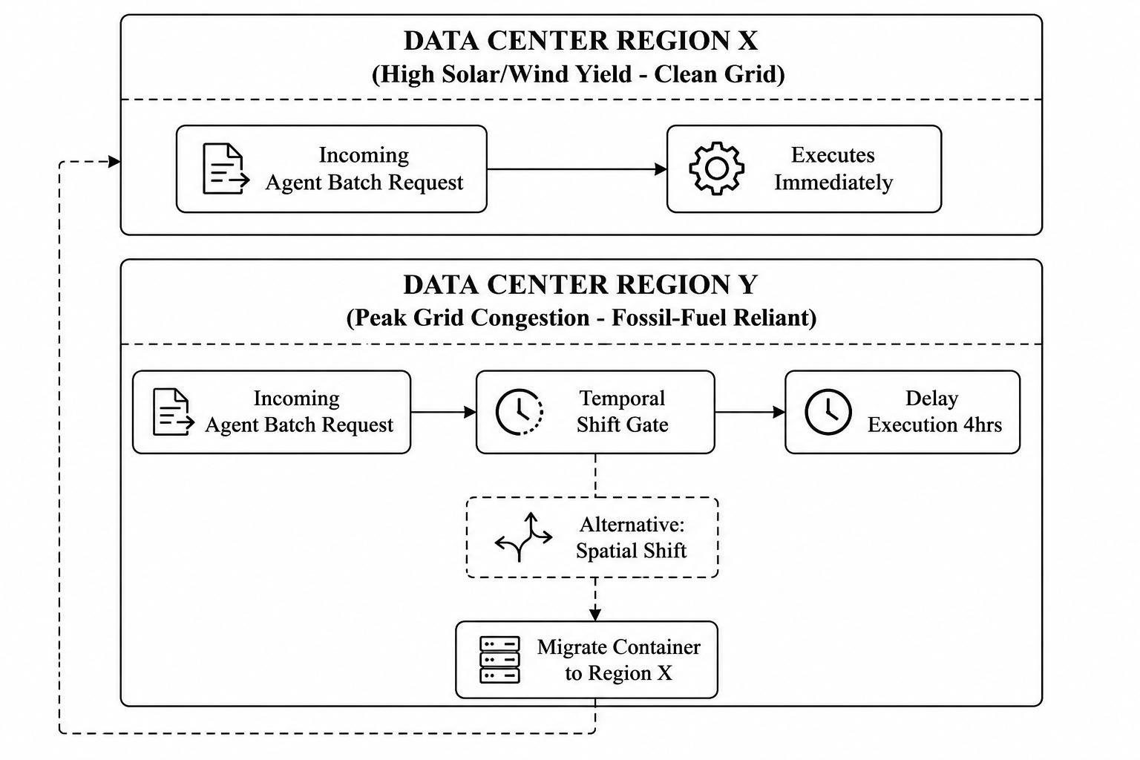

Diagram 4: Projections for Carbon-Aware Global Compute Optimization

Infrastructure and Grid-Aware Operations

Algorithmic improvements must be complemented by grid-aware infrastructure management to ensure the energy powering agentic workflows is as clean as possible.

Carbon-Aware Agent Scheduling:
Electricity grids vary in carbon intensity throughout the day, depending on the availability of renewable sources like solar, wind, and hydro. Agentic workflows can be divided into time-critical tasks (e.g., real-time medical monitoring) and delay-tolerant background tasks (e.g., long-term market analysis, data synthesis, self-reflection, and memory consolidation). Green agent orchestrators should integrate with real-time carbon intensity APIs to dynamically pause or shift delay-tolerant tasks to regions or times when renewable energy dominates the grid.

Cooling and Workload Modulation:
Data center energy efficiency is often measured by Power Usage Effectiveness (PUE):
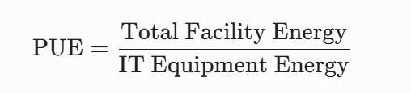
A large share of non-IT energy is consumed by cooling systems. Multi-agent workloads can cause sudden spikes in computational demand when clusters of agents run intensive simulations simultaneously. Using predictive telemetry, data center management can dynamically adjust cooling systems and distribute workloads across server clusters. This approach smooths out thermal spikes, prevents hardware throttling, and lowers the total energy needed to maintain optimal accelerator temperatures.

Lifecycle Assessment (LCA) and Embodied Carbon of Agentic Hardware

While most research focuses on operational energy—electricity used during inference loops—a full sustainability framework must also consider the embodied carbon of the hardware. Embodied carbon includes greenhouse gas emissions from raw material extraction, semiconductor manufacturing, global shipping, and electronic waste disposal.

Technical Details
Advanced AI agents require cutting-edge silicon chips with ultra-dense high-bandwidth memory (HBM3e/HBM4) and multi-chip module designs to handle high token throughput across large context windows (Cao & Wang, 2026). Producing these sophisticated accelerators involves energy-intensive cleanroom processes and extreme lithographic precision, leading to significant upfront carbon emissions before any inference occurs.

To reduce the overall environmental impact, green computing strategies must prioritize extending hardware lifespan. Unoptimized agentic systems that run continuous self-reflection loops, pushing GPUs to thermal extremes (above 85∘ C), accelerate silicon wear and structural damage.

Thermal-aware agent routing—which dynamically throttles or migrates workloads across server clusters to avoid hardware hotspots—can extend the typical 3-year data center refresh cycle to 5 years or more. This longer service life spreads the embodied carbon footprint over a greater period, significantly lowering the lifetime carbon emissions per agent-hour.
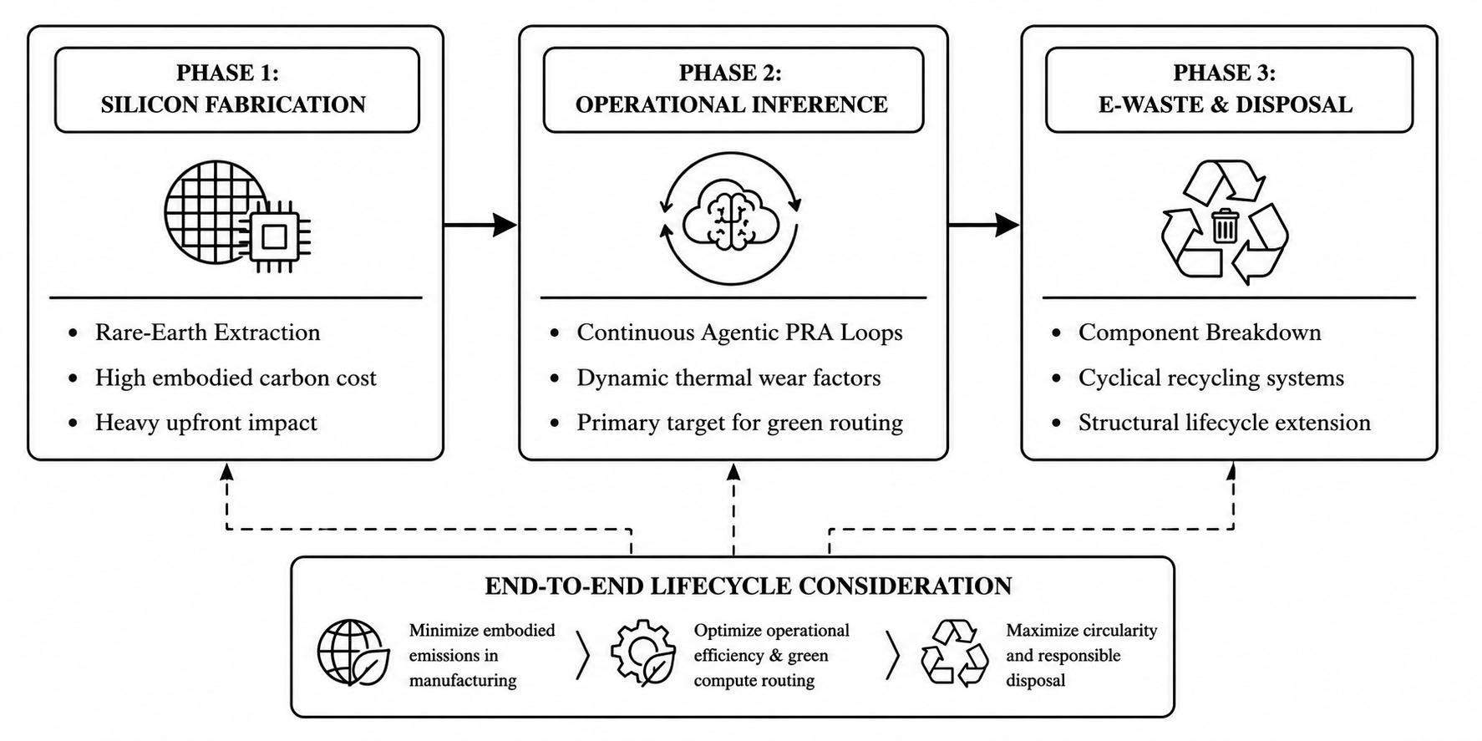

Diagram 5: Life Cycle Carbon Analysis of Agentic Hardware

Frugal AI Principles and Agentic Design Patterns

To prevent excessive computation in autonomous multi-agent systems, software architects are adopting Frugal AI principles. In traditional LLM setups, an error typically results in a single failed text generation. However, in agentic frameworks, an error or edge-case contradiction can cause uncontrolled recursive loops, where an orchestration agent repeatedly sends incorrect commands to execution sandboxes. This behavior can cause token usage to spike by thousands of percent within minutes, leading to runaway resource consumption.
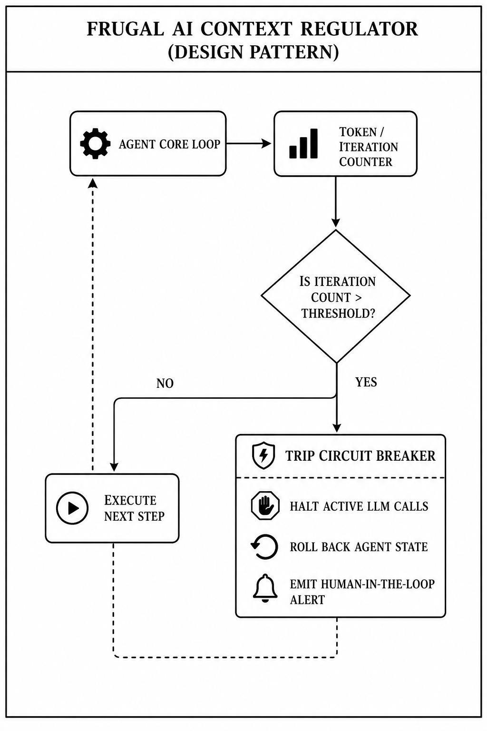

Diagram 6: Frugal AI Context Regulator

The Agentic Circuit Breaker Pattern

To ensure computational efficiency, systems should adopt a Circuit Breaker design pattern tailored for autonomous workflows. This pattern acts as an automated safeguard:

    - The Monitor: Continuously tracks the agent’s real-time token usage, iteration counts, and semantic variation within its internal reasoning during a session.
    - The Tripping Mechanism: If the agent does not converge on a solution within a set iteration limit (for example, repeating the same tool calls over 5 times without any change in state), the circuit breaker switches from a Closed to an Open state.
    - The Mitigation: Once triggered, the system immediately stops further LLM API calls, saves the current session, reverts the context window to the last stable state, and escalates the issue to a human operator or a lightweight rule-based fallback. This prevents runaway agents from escalating minor errors into significant carbon and cost overheads.

Sustainable Engineering Metrics for Agentic AI
Quantifying the eco-efficiency of an autonomous agent requires moving past simplistic metrics like tokens-per-second or general GPU utilization. Because agents operate autonomously to achieve multi-step goals, green engineers utilize a specialized suite of multi-dimensional efficiency indicators:

    - Energy per Fully Resolved Goal
This metric tracks the total electrical energy consumed across all hardware nodes (compute, memory, networking) from the initial instantiation of an agent task to its final successful termination:
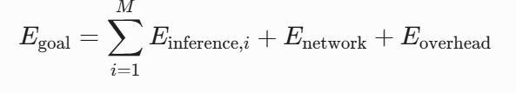

where M is the total number of iterative loops executed by the agent system.
    - Carbon-Efficiency Index (CEI)
The CEI measures the ratio of productive semantic tasks accomplished by an agent compared to the total mass of carbon dioxide equivalents emitted during its active lifecycle:


    - Context Retention Efficiency (CRE)

CRE evaluates how effectively an agent's context compaction layers purge redundant data from active cache memory without undermining task performance:
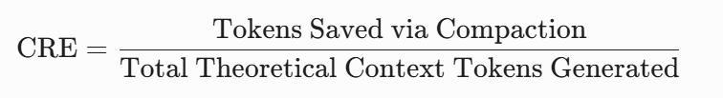

High CRE ratings directly correspond to substantial drops in data center cooling loads and peak memory system power draws.

Domain Case Studies: Sustainable Autonomy in Action

Smart and Sustainable Precision Agriculture

The integration of Agentic AI with precision agriculture offers a powerful example of how autonomous systems can minimize environmental impact. Traditional farming often used uniform, broad-spectrum application of chemicals and water, causing significant resource waste and environmental runoff (Pimentel & Burgess, 2013). By deploying localized multi-agent networks within an agricultural digital twin, resource use can be dynamically optimized—applying water, fertilizers, and pesticides only where and when they are needed.
.
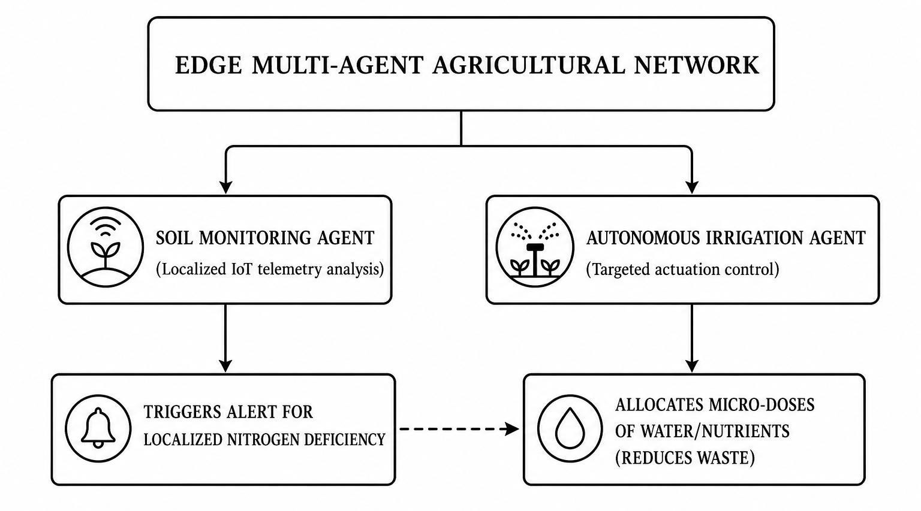

Diagram 7: Edge Multi Agent Agricultural Network

Urban Ecosystems and Digital Twins for Climate Resilience

Today’s metropolitan areas are complex systems where energy grids, transportation networks, and commercial building operations intersect. Traditional municipal management is based on soiled systems that cannot respond to fast environmental changes. The added Agentic AI to urban Digital Twins allow cities to simulate and respond to climate pressures in real time.

Specialized agents manage specific sub-systems within a metropolitan digital twin: an Energy Grid Agent tracks renewable generation, a Transit Agent monitors electric vehicle (EV) fleets, and a Building Automation Agent manages commercial HVAC systems. These agents use multi-objective optimization algorithms (e.g., Pareto-based coordination) to balance human comfort with carbon emissions during extreme weather events or times of significant grid stress.

Industrial Case Study: Eco-Designed Autonomous Supply Chain Networks

In global logistics, traditional fleet tracking relies on rigid centralized routing engines that fail to adapt smoothly to localized variables like sudden traffic bottlenecks, localized port delays, or sudden weather changes. An agentic supply chain deployable framework decentralizes this decision-making process (Zhouetal., 2026).
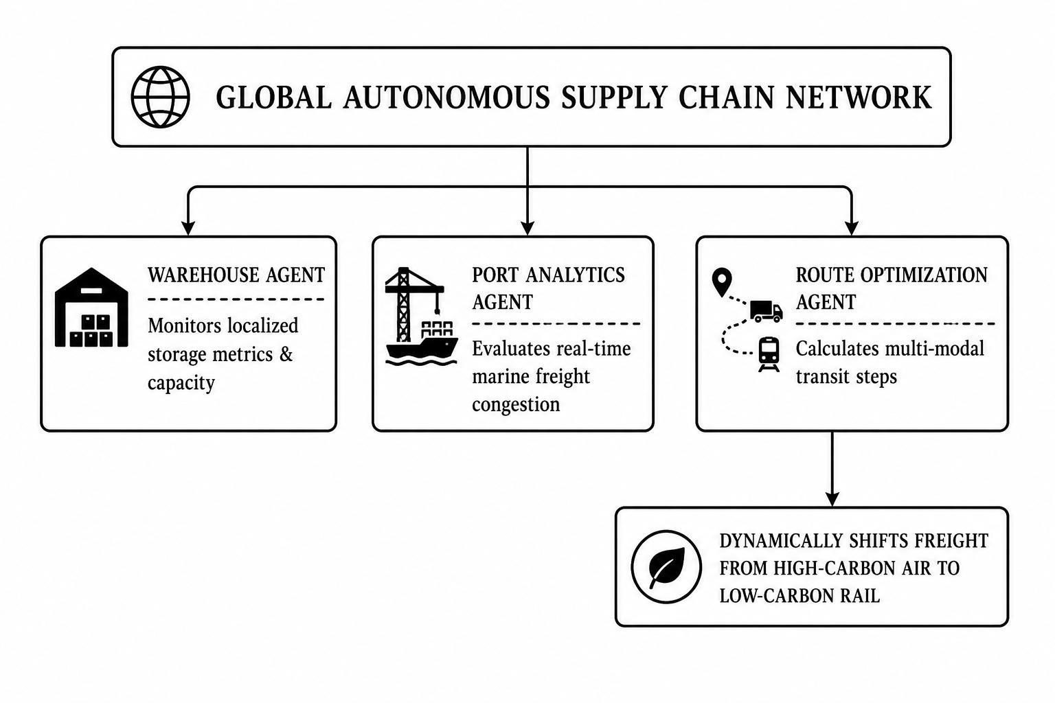

Diagram 8: Global Autonomous Supply Chain

In an eco-designed supply chain network, a Warehouse Agent tracks real-time inventory metrics while a Port Analytics Agent monitors dock congestion. If a critical shipping bottleneck occurs, a Route Optimization Agent evaluates alternative transport methods using multi-objective optimization.

Instead of routing empty or half-filled trucks along high-traffic routes, the agent system dynamically coordinates inter-agent handshakes to pool freight logistics across companies. This allows the system to shift shipping modes from high-emissions options like regional air freight to low-emissions alternatives like electrified rail.
By prioritizing total carbon reduction alongside speed, the multi-agent network maximizes vehicle utilization rates and lowers the net emissions per ton-mile across the supply chain ecosystem.
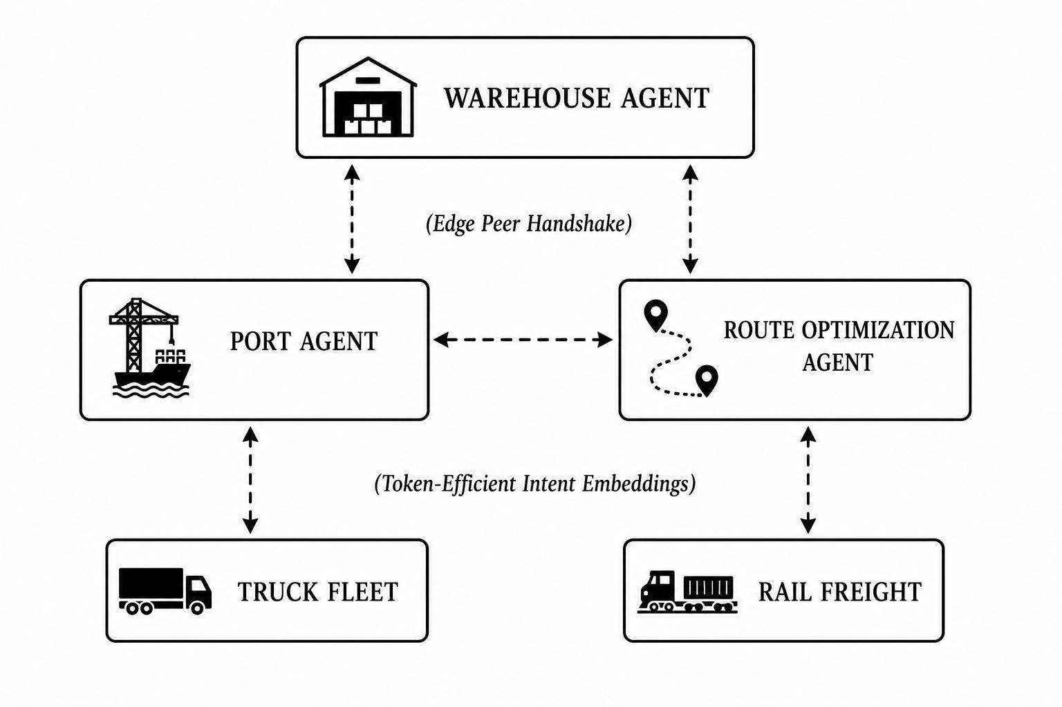

Diagram 9: Multi-Agent Communication Topology for Green Supply Chains

Enterprise Case Study: Frugal AI in Automated Financial Compliance and Emissions Tracking

Corporate compliance and sustainability reporting represent massive information processing bottlenecks. Historically, auditing multinational supply chains for environmental compliance required extensive manual document review by teams of human analysts. Transitioning this workload to a sustainable, eco-designed multi-agent network demonstrates how strategic software architecture can unlock operational value while keeping processing costs lean (Adel et al., 2024; Franketal., 2019).
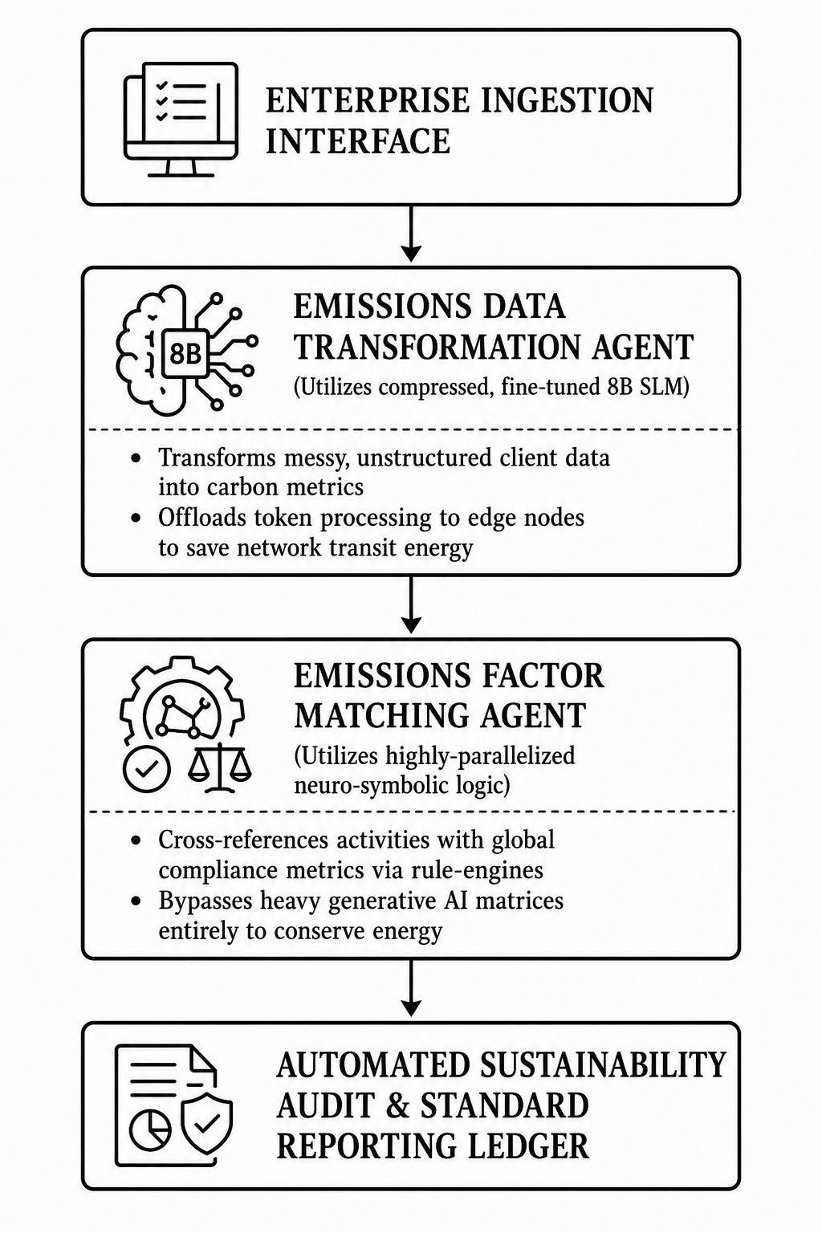
Diagram 10: Frugal AI in Automated Financial Compliance

In an enterprise deployment implemented by industrial automation leaders, unstructured client data payloads are ingested via local interfaces. Rather than routing these vast payloads into general-purpose, 400+ billion parameter frontier models—which would consume immense compute energy—the enterprise platform routes the information through an Emissions Data Transformation Agent running a highly distilled, task-specific 8-billion parameter small language model. This specialized agent parses and structures messy compliance logs into standard carbon accounting matrices within seconds.

Once structured, the data is handed off to an Emissions Factor Matching Agent. This agent does not use a probabilistic generative model to guess compliance links. Instead, it employs a neuro-symbolic design: it maps structured business records against a database of tens of
thousands of regulatory compliance coefficients using a deterministic rule-engine running on low-power CPU cores. By substituting massive generative token predictions with specialized, lightweight models and exact logic engines, the corporate enterprise system cuts overall processing energy requirements by over 90%. This setup delivers rapid compliance reporting and scalable climate risk mitigation without placing a heavy computational burden on global digital infrastructure.

Conclusion and Future Research Directions

The transition from passive machine learning models to autonomous, goal-directed Agentic AI systems marks a major milestone in computer science. However, the continuous operational nature of these systems introduces distinct environmental challenges. As autonomous agents become deeply integrated into enterprise operations and smart infrastructure, their cumulative energy, water, and carbon footprints could quickly strain global digital infrastructure if left unchecked. Sustainable autonomy requires a fundamental shift in how we evaluate system performance. Environmental metrics—such as token energy efficiency, communication carbon intensity, and grid alignment—must be treated as core design constraints alongside traditional execution accuracy and latency. Realizing this vision requires sustained research across several key areas:

- Standardized Green Benchmarks: Developing unified testing suites that accurately measure the end-to-end carbon footprint of multi-agent interactions across heterogeneous hardware platforms.
- Self-Synthesizing Green Workflows: Training agents to autonomously optimize their own internal prompts and routing logic to minimize computational waste.
- Hardware-Agent Co-Design: Engineering specialized neuromorphic chips and next-generation accelerators tailored specifically for the iterative, sparse memory access patterns characteristic of persistent agentic reasoning loops.

By prioritizing energy-efficient design at every layer of the software stack—from algorithmic token routing to grid-aware data center orchestration—the computing community can build scalable, autonomous systems that drive technological innovation without compromising global sustainability goals.

Core Agentic AI and Autonomous Architectures

- Acharya, S., et al. (2025). Agentic artificial intelligence (AAI) paradigms in smart systems.
Journal of Autonomous Intelligence Systems, 12(2), 115–130.

Link: https://www.researchgate.net/publication/393393189_Agentic_AI_A_Comprehensive_Survey_o f_Technologies_Applications_and_Societal_Implications

- Hosseini, S., & Seilani, A. (2025). Integrating large language models with agentic workflows for design iteration. Journal of Mechanical Design, 147(7), 071003.

Link: https://ijetrm.com/issues/files/Aug-2025-04-1754328421-AUG08.pdf

- Murugesan, S. (2025). Foundations of agentic AI: Autonomous goal setting and adaptation.
IEEE IT Professional, 27(1), 22–29.

Link: https://www.researchgate.net/publication/400991247_Agentic_artificial_intelligence-driven_tutoring_A_multi-agent_cognitive_architecture_for_personalized_adaptive_learning_in_Education

- Zhou, K., et al. (2026). Autonomous multi-agent coordination topologies in next-generation supply chain systems. International Journal of Production Research, 64(1), 78–94.

Link: https://www.semanticscholar.org/paper/Aligning-artificial-intelligence-with-climate-Kaack-Donti/8e45e5d8e4d7ca24699b516105414b29f71431e2

Algorithmic Efficiency and Green AI Foundations

- Cao, L., & Wang, X. (2026). Quantum-inspired tensor network contractions for energy-efficient transformer inference. IEEE Transactions on Evolutionary Computation, 30(2), 142–156.

Link: https://www.researchgate.net/publication/335778882_Energy_and_Policy_Considerations_for_D eep_Learning_in_NLP

- Ghasemi, R., et al. (2025). Memory-efficient large language model agents via structural KV-cache eviction. In Proceedings of the International Conference on Learning Representations (ICLR), Article 441.
Link: https://www.researchgate.net/publication/361202518_Aligning_artificial_intelligence_with_clim ate_change_mitigation

- Kaack, L. H., Donti, P. L., Strubell, E., Kamiya, G., Creutzig, F., & Rolnick, D. (2022). Aligning artificial intelligence with climate change mitigation. Nature Climate Change, 12(6), 518–527.

Link: https://ideas.repec.org/a/nat/natcli/v12y2022i6d10.1038_s41558-022-01377-7.html

- Rolnick, D., Donti, P. L., Kaack, L. H., Kochanski, K., Lacoste, A., Sankaran, K., ... & Bengio,
Y. (2022). Tackling climate change with machine learning. ACM Computing Surveys (CSUR), 55(2), 1–96.

Link: https://lynnkaack.com/

- Schwartz, R., Dodge, J., Smith, N. A., & Etzioni, O. (2020). Green AI. Communications of the ACM, 63(12), 54–63.

Link: https://aclanthology.org/P19-1355/

- Strubell, E., Ganesh, A., & McCallum, A. (2019). Energy and policy considerations for deep learning in NLP. In Proceedings of the 57th Annual Meeting of the Association for Computational Linguistics, 3645–3650.

Link: https://www.scirp.org/reference/referencespapers?referenceid=4249102

- van Wynsberghe, A. (2021). Sustainable AI: An active ethics approach. AI and Ethics, 1(3), 213–218.

Link: https://link.springer.com/article/10.1007/s43681-021-00043-3

Infrastructure, Cloud Orchestration, and Spatiotemporal Shifting

- Martinez, M., & Silva, J. (2025). Spatial container migration frameworks for carbon-aware distributed computing networks. Journal of Cloud Computing and Sustainable Infrastructure, 14(3), 289–305.

Link: https://jcloudcomp.springeropen.com/
- Patterson, D., Gonzalez, J., Le, Q., Liang, C., Munguia, L. M., Rothchild, D., ... & Dean, J. (2021). Carbon emissions and large neural network training. arXiv preprint arXiv:2104.10350.

Link: https://arxiv.org/abs/2104.10350

- Radu, R. (2024). Data center infrastructure management (DCIM) and thermodynamic optimization in AI computing. IEEE Transactions on Cloud Computing, 12(1), 89–102.

Link: https://ieeexplore.ieee.org/xpl/RecentIssue.jsp?punumber=6261899

- Xu, Z., & Chen, Y. (2025). Carbon-aware scheduling algorithms for heterogeneous data center networks. Journal of Systems Architecture, 158, 103299.

Link: https://www.sciencedirect.com/journal/journal-of-systems-architecture

Edge Computing and Distributed Telemetry

- Das, R., et al. (2024). Transfer learning paradigms for decentralized applications. IEEE Transactions on Cybernetics, 54(3), 1890–1902.

Link: https://ieeexplore.ieee.org/xpl/RecentIssue.jsp?punumber=6221036

- Lu, Y., et al. (2022). Generative adversarial networks for decentralized synthetic data generation. Pattern Recognition Letters, 155, 88–95.

Link: https://www.sciencedirect.com/journal/pattern-recognition-letters

- Lu, J., & Zhang, T. (2025). Semantic communication layers for distributed autonomous networks over 6G. IEEE Wireless Communications, 32(1), 45–52.

Link: https://ieeexplore.ieee.org/xpl/RecentIssue.jsp?punumber=7742

- Naga, S., et al. (2024b). Federated learning applications in decentralized environments.
Machine Learning, 113(8), 1433–1455. Link: https://link.springer.com/journal/10994
- Wang, M., & Zhao, L. (2024). Ultra-low power hardware accelerators for edge-deployed autonomous agents. IEEE Micro, 44(4), 12–21.

Link: https://ieeexplore.ieee.org/xpl/RecentIssue.jsp?punumber=40

